Importing SiteTools Results

You will again be reminded of what is going to happen. It is important to note that any previous import from SiteTools will be deleted and replaced with the import.
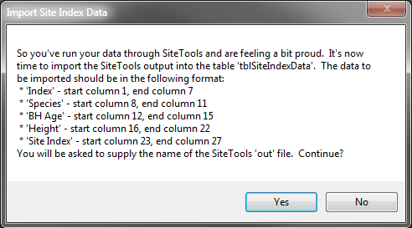
The data will first be read into the table “tblSiteIndexData”. The site index values will then be read into your current project’s Tree table.
Again, the ever-welcome Task complete message will be displayed.
